IS312 Web Design and Programming: Introduction to JavaScript
HOS03 Experiencing JavaScript and DOM
10/08/2025 Reviewed by Ashwin Paturi
5/30/2026 Revised by Jonathan Koerber
9/01/2026 Reviewed by Akshita Modi

School of Technology & Computing (STC) @ City University of Seattle (CityU)


Before You Start
- Version numbers may not match the most current version at the time of writing. If given the option to choose between a stable release (long-term support) and the most recent version, please select the stable release rather than the beta-testing version.
- This tutorial targets Windows users and macOS users.
- There might be subtle discrepancies along with the steps. Please use your best judgment as you follow this cookbook-style tutorial to complete each step.
- For your working directory, use your course number, i.e., IS312. This tutorial may use a different course number as an example. The path or content shown in the screenshots is not necessarily the same as the text description. If there is a conflict, follow the text rather than screenshots.
- Feel free to contact your course TA.

Learning Outcomes
- Understanding JavaScript (JS)
- Understanding HTML Document Object Model (DOM)

Activities
- Preparing for a MEAN project environment
- Experiencing client-side JavaScript

Stack Overflow 2021 Developer Survey
Programming, scripting, and markup languages: https://survey.stackoverflow.co/2024/technology#1-programming-scripting-and-markup-languages
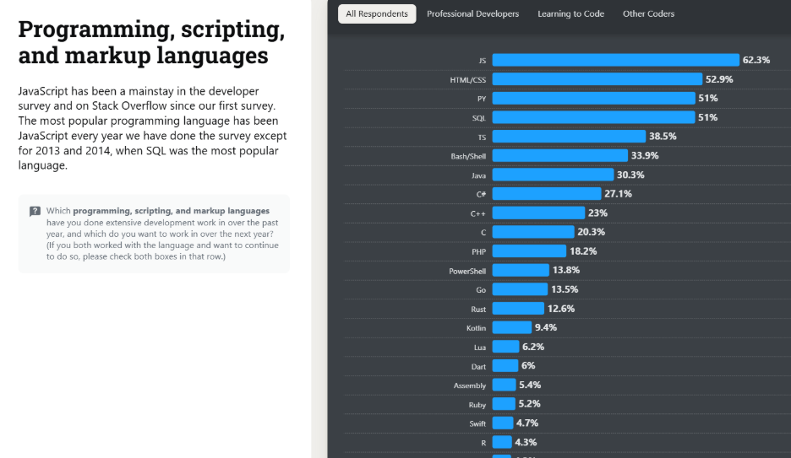

JavaScript: https://en.wikipedia.org/wiki/JavaScript
  - “A programming language that conforms to the ECMAScript specification”
  - “JavaScript is high-level, often just-in-time compiled and multi-paradigm.”
  - “JavaScript has dynamic typing, prototype-based object-orientation, and first-class functions.
  - “JavaScript supports event-driven, functional, and imperative programming styles.”
  - “JavaScript has application programming interfaces (APIs) for working with text, dates, regular expressions, standard data structures, and the Document Object Model (DOM).
  - “JavaScript engines were originally used only in web browsers, but they are now core components of some servers and a variety of applications. The most popular runtime system for this usage is Node.js.”
  - “Although there are similarities between JavaScript and Java, including language name, syntax, and respective standard libraries, the two languages are distinct and differ greatly in design.”
- For further study, visit https://www.w3schools.com/js/default.asp

Document Object Model (DOM) - https://en.wikipedia.org/wiki/Document_Object_Model

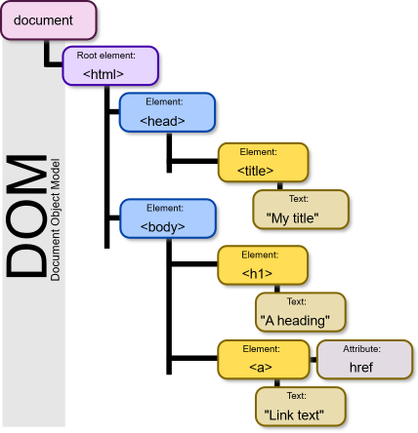
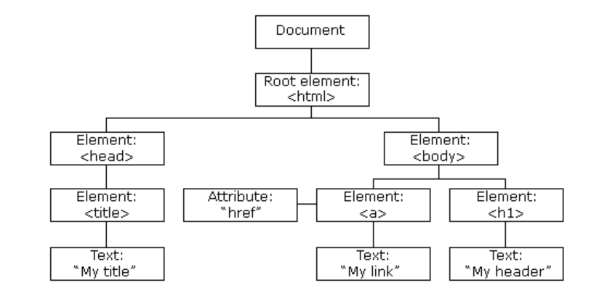
  - “A cross-platform and language-independent interface that treats an XML or HTML document as a tree structure wherein each node is an object representing a part of the document.”
  - “The DOM represents a document with a logical tree. Each branch of the tree ends in a node, and each node contains objects.”
  - “When a web page is loaded, the browser creates a DOM of the page, which is an object-oriented representation of an HTML document that acts as an interface between JavaScript and the document itself. This allows the creation of dynamic web pages, because within a page, JavaScript can:
    - add, change, and remove any of the HTML elements and attributes
    - change any of the CSS styles
    - react to all the existing events
    - create new events”
- For further study, visit https://www.w3schools.com/js/js_htmldom.asp

Client-Side Dynamic Web Page - https://en.wikipedia.org/wiki/Dynamic_web_page
  - A client-side dynamic web page processes the web page using JavaScript running in the browser as it loads. JavaScript can interact with the page via the DOM to query the page state and modify it.

Some critical/popular libraries:
- jQuery
  - jQuery is a fast, small, and feature-rich JavaScript library released by John Resig in January 2006. jQuery offers excellent DOM manipulation encapsulation, convenient AJAX manipulation, and impressive animation effects. Its appearance greatly simplifies writing JavaScript and accelerates web development. It even affects today's HTML5 standard, and many APIs related to DOM manipulation in JS have absorbed jQuery's ideas. jQuery is a library well worth the time to learn.

- React / Angular / Vue
  - These three frameworks componentize Web pages and render them dynamically through JS. A component receives inputs, performs internal computations, and then returns a rendered UI template as its output. The defined components should be easy to reuse in web pages or other components. Componentization means that HTML/CSS code can be encapsulated and reused, which is of great significance for web front-end engineering.

Section 1 - Preparing the environment
- Create a new folder named IS312_module03_<yourName> and open it with VS Code. (replace <yourName> with your first name and last name)
- Press Ctrl + ` in VS Code to open the terminal. Type the following command to create a directory called HOS03-js in the IS312_module03_<yourName>/ folder.
$ mkdir HOS03-js

Section 2 - Experiencing a client-side JavaScript
- Create a “public” directory under the “HOS03-js” directory.
- So, the resulting structure should look like:

Example:
IS312_module03_<yourName>/
└── HOS03-js/
└── public/

- Create an “index.html” file under the “public” directory.

Structure looks like this
Example
IS312_module03_<yourName>/
└── HOS03-js/
└── public/
└── index.html

- Open the index.html file in the public directory and add the following HTML code.

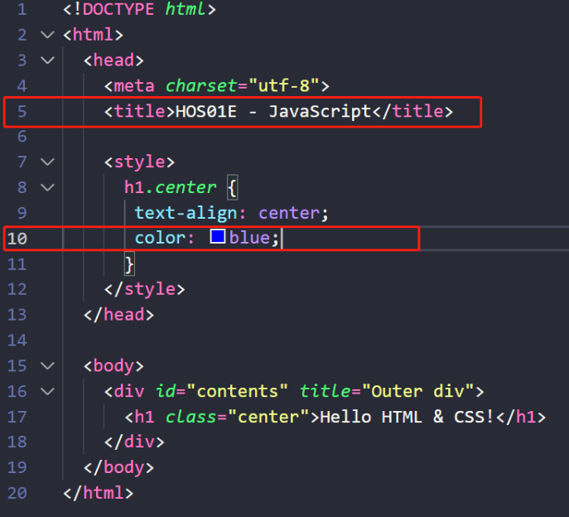
- By right clicking the file, select the “Reveal in File Explorer” menu.
- Then, open the file in your browser. Check the title and color of the content of the web page.
You should also be able to hover over the text or anywhere to its right side within the boundaries of the outer div, and you should be able to see the tooltip “Outer div” pop up.
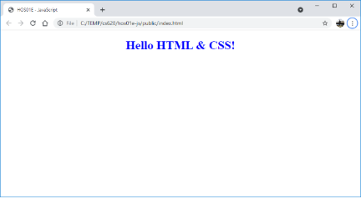

- Change the content of the <h1> element to “Hello JavaScript!” - Then, by using JavaScript, we want to display it.
  - To access the <h1> element, the element needs its ID - Check line 17.
  - In HTML, JavaScript code is inserted between <script> and </script> tags - Check lines 20 and 21.
  - To access an HTML element, JavaScript can use the document.getElementById(id) method. The id attribute defines the HTML element. The innerHTML property defines the HTML content - Check lines 21.

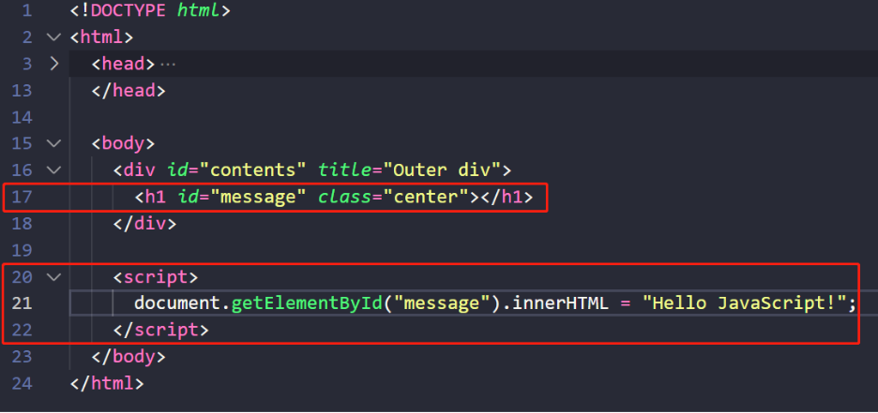

- By right-clicking the file, select the “Reveal in File Explorer” menu.
- Then, open the file in your browser. Check the title of the web page.
You should also be able to hover over the text or anywhere to its right side within the boundaries of the outer div, and you should be able to see the tooltip “Outer div” pop up.
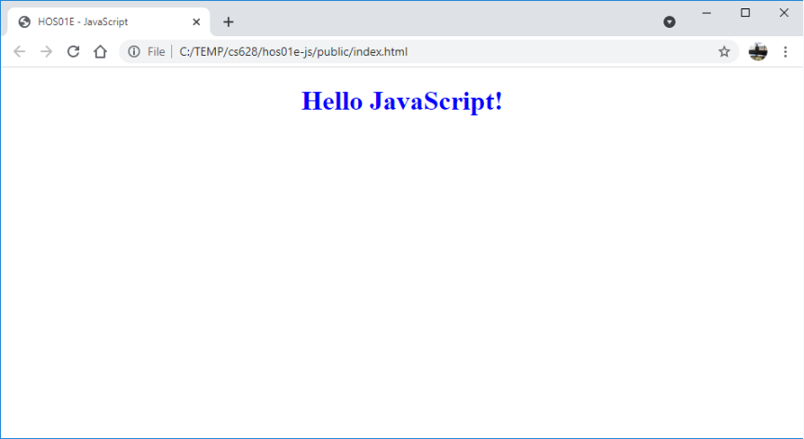

- By right-clicking on your web browser, select the “Inspect” item from the menu. Check each HTML tag in the “Elements” tab.
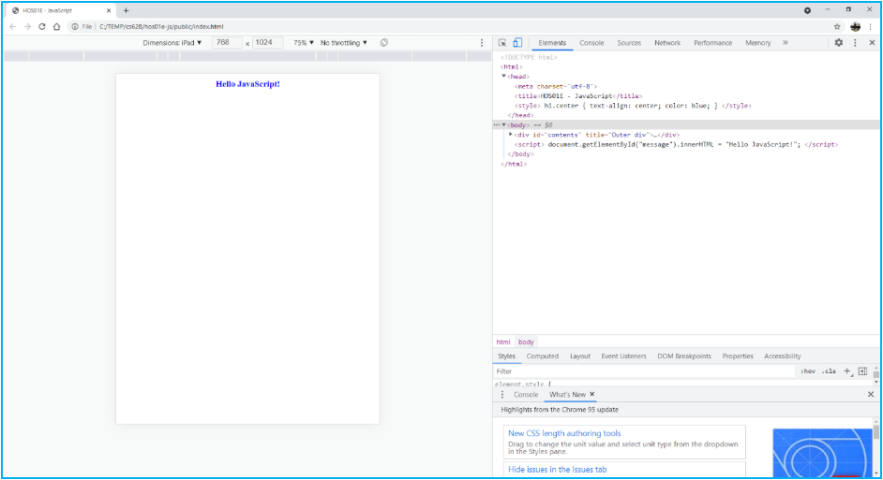
- Next, we are going to explore more about how to manipulate elements in the DOM with JavaScript by using variables, conditional statements, loops and functions. If you have questions to review this week, reading covers all of this in more detail. Right now, we have just one element in our DOM which is our title. Let's make a little animation where the inner balls roll around the outer circle.
- Add the following code to our html section.
- In the style section, let's create a style rule for the outer box and the inner box. So, we have a ring and an inner ball.
- Now we have our ring and our inner ball. You most likely can really see the inner ball as it is just sticking out from behind the containers circle. Now we have our DOM elements we are now going do the rest with JavaScript. Unlike when we overwrite our h1 element, we need to create a way for us to hold values. JavaScript has two types of variables constants const that will not change, and ones that do we can either use let of var for those.
We’ll use let as it will be a local variable that change like the angle and speed and const for our DOM elements, as well as our contents values like the container size ball size and center of each. The value that will change we is the angle and speed.
- Next, we need to create a function that will calculate the angle for that we need some algebra. Instead of tracking X and Y coordinates directly, we track an angle ($\theta$). As the angle increases from 0 to 360 degrees (or 0 to 2PI in radians), the ball follows a circular path.
- Now we need to implement a function to do this. We start with the JS keywork function followed by the name of the function and a pair of parentheses. If there was an argument that we could pass the function, it would go into the presentists and a curly brace. Each time the function runs, we calculate where the center of the inner ball will be. Then we use the built-in function requestAnimationFrame to call the function.
- We can create add gravity, so the ball slows as it rises. We need to add a gravity variable defined under the other variables. Inside the function, we need to calculate speed and can add these calculations.
- You should end up with something like this.

Push your work to GitHub: Refer to the page below on how to clone a Git repo and push the changes - Uploading Files in GitHub

